Coronavirus disease 2019 (COVID-19)
Situation Report – 44

Data as reported by national authorities by 10AM CET 04 March 2020

HIGHLIGHTS

- Four new Member States (Argentina, Chile, Poland and Ukraine) have reported cases of COVID-19 in the past 24 hours.

- The WHO Prequalification Team announced that the Emergency Use Listing (EUL) is now open to candidate in-vitro diagnostic (IVD) laboratory tests to detect COVID-19 virus. The EUL procedure is developed to expedite the availability of IVDs needed in public health emergency situations. Manufacturers are invited to submit an Expression of Interest. Further information can be found here.

- Disruptions to the global supply of personal protective equipment (PPE) are leaving healthcare workers ill-equipped to care for patients. WHO is working with governments, industry and the Pandemic Supply Chain Network to boost production and secure allocations for critically affected and at-risk countries. More information can be found here.
SITUATION IN NUMBERS
total and new cases in last 24 hours

Globally
93 091 confirmed (2223 new)

China
80 422 confirmed (120 new)
2984 deaths (38 new)

Outside of China
12 669 confirmed (2103 new)
76 countries (4 new)
214 deaths (48 new)

WHO RISK ASSESSMENT

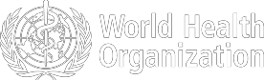
- The COVID-19 Operational Planning Guidelines and COVID-19 Partners Platform to support country preparedness and response course in English has been added to OpenWHO. Please see all COVID-19 courses on OpenWHO here.
China | Very High
Regional Level | Very High
Global Level | Very High

Figure 1. Countries, territories or areas with reported confirmed cases of COVID-19, 04 March 2020

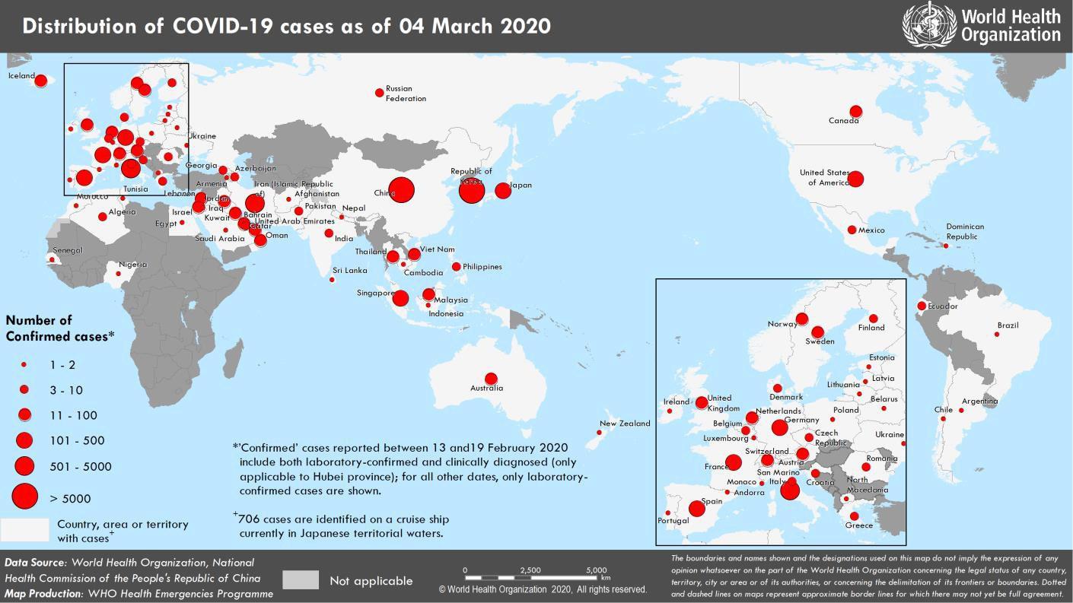

SURVEILLANCE

Table 1. Confirmed and suspected cases of COVID-19 acute respiratory disease reported by provinces, regions and cities in China, Data as of 04 March 2020
Province/ Region/ | Population (10,000s) | Confirmed | In last 24 hours Suspected |  | Cumulative  Confirmed Deaths
City | cases |  | cases | Deaths | cases
Hubei | 5917 | 115 | 52 | 37 | 67332 |  | 2871
Guangdong | 11346 | 0 | 0 | 0 | 1350 |  | 7
Henan | 9605 | 0 | 0 | 0 | 1272 |  | 22
Zhejiang | 5737 | 0 | 2 | 0 | 1213 |  | 1
Hunan | 6899 | 0 | 0 | 0 | 1018 |  | 4
Anhui | 6324 | 0 | 0 | 0 | 990 |  | 6
Jiangxi | 4648 | 0 | 0 | 0 | 935 |  | 1
Shandong | 10047 | 0 | 0 | 0 | 758 |  | 6
Jiangsu | 8051 | 0 | 0 | 0 | 631 |  | 0
Chongqing | 3102 | 0 | 1 | 0 | 576 |  | 6
Sichuan | 8341 | 0 | 1 | 0 | 538 |  | 3
Heilongjiang | 3773 | 0 | 2 | 0 | 480 |  | 13
Beijing | 2154 | 3 | 11 | 0 | 417 |  | 8
Shanghai | 2424 | 0 | 19 | 0 | 338 |  | 3
Hebei | 7556 | 0 | 0 | 0 | 318 |  | 6
Fujian | 3941 | 0 | 0 | 0 | 296 |  | 1
Guangxi | 4926 | 0 | 0 | 0 | 252 |  | 2
Shaanxi | 3864 | 0 | 0 | 0 | 245 |  | 1
Yunnan | 4830 | 0 | 2 | 0 | 174 |  | 2
Hainan | 934 | 0 | 0 | 0 | 168 |  | 5
Guizhou | 3600 | 0 | 0 | 0 | 146 |  | 2
Tianjin | 1560 | 0 | 17 | 0 | 136 |  | 3
Shanxi | 3718 | 0 | 0 | 0 | 133 |  | 0
Liaoning | 4359 | 0 | 36 | 0 | 125 |  | 1
Hong Kong SAR | 745 | 0 | 0 | 0 | 100 |  | 2
Jilin | 2704 | 0 | 0 | 0 | 93 |  | 1
Gansu | 2637 | 0 | 0 | 0 | 91 |  | 2
Xinjiang | 2487 | 0 | 0 | 0 | 76 |  | 3
Ningxia | 688 | 1 | 0 | 0 | 75 |  | 0
Inner Mongolia | 2534 | 0 | 0 | 1 | 75 |  | 1
Taipei and environs | 2359 | 1 | 0 | 0 | 42 |  | 1
Qinghai | 603 | 0 | 0 | 0 | 18 |  | 0
Macao SAR | 66 | 0 | 0 | 0 | 10 |  | 0
Xizang | 344 | 0 | 0 | 0 | 1 |  | 0
Total | 142823 | 120 | 143 | 38 | 80422 |  | 2984

Table 2. Countries, territories or areas outside China with reported laboratory-confirmed COVID-19 cases and deaths. Data as of 04 March 2020^
Reporting Country | Total confirmed* cases | Total confirmed new cases | Total deaths | Total new deaths | Transmission  † | Days since last reported case**
Western Pacific Region
Republic of Korea | 5328 | 516 | 32 | 4 | Local transmission | 0
Japan | 284 | 16 | 6 | 0 | Local transmission | 0
Singapore | 110 | 2 | 0 | 0 | Local transmission | 0
Malaysia | 50 | 21 | 0 | 0 | Local transmission | 0
Australia | 43 | 10 | 1 | 0 | Local transmission | 0
Viet Nam | 16 | 0 | 0 | 0 | Local transmission | 20
Philippines | 3 | 0 | 1 | 0 | Imported cases only | 28
New Zealand | 2 | 0 | 0 | 0 | Imported cases only | 1
Cambodia | 1 | 0 | 0 | 0 | Imported cases only | 36
European Region
Italy | 2502 | 466 | 80 | 28 | Local transmission | 0
France | 212 | 21 | 4 | 1 | Local transmission | 0
Germany | 196 | 39 | 0 | 0 | Local transmission | 0
Spain | 151 | 37 | 0 | 0 | Local transmission | 0
the United Kingdom¶ | 51 | 12 | 0 | 0 | Local transmission | 0
Switzerland | 37 | 7 | 0 | 0 | Local transmission | 0
Norway | 33 | 7 | 0 | 0 | Local transmission | 0
Netherlands | 28 | 10 | 0 | 0 | Local transmission | 0
Austria | 24 | 6 | 0 | 0 | Imported cases only | 0
Sweden | 24 | 9 | 0 | 0 | Local transmission | 0
Iceland | 16 | 7 | 0 | 0 | Imported cases only | 0
Israel | 12 | 2 | 0 | 0 | Local transmission | 0
Croatia | 9 | 1 | 0 | 0 | Local transmission | 0
Belgium | 8 | 0 | 0 | 0 | Imported cases only | 1
Denmark | 8 | 3 | 0 | 0 | Local transmission | 0
San Marino | 8 | 0 | 0 | 0 | Local transmission | 1
Finland | 7 | 0 | 0 | 0 | Local transmission | 1
Greece | 7 | 0 | 0 | 0 | Local transmission | 2
Czechia | 5 | 2 | 0 | 0 | Imported cases only | 0
Romania | 4 | 1 | 0 | 0 | Local transmission | 0
Azerbaijan | 3 | 0 | 0 | 0 | Imported cases only | 3
Georgia | 3 | 0 | 0 | 0 | Imported cases only | 3
Russian Federation | 3 | 0 | 0 | 0 | Imported cases only | 1
Estonia | 2 | 1 | 0 | 0 | Imported cases only | 0
Ireland | 2 | 1 | 0 | 0 | Imported cases only | 0
Portugal | 2 | 0 | 0 | 0 | Imported cases only | 1
Andorra | 1 | 0 | 0 | 0 | Imported cases only | 1
Armenia | 1 | 0 | 0 | 0 | Imported cases only | 2
Belarus | 1 | 0 | 0 | 0 | Imported cases only | 5
Latvia | 1 | 0 | 0 | 0 | Imported cases only | 1
Lithuania | 1 | 0 | 0 | 0 | Imported cases only | 5
Luxembourg | 1 | 0 | 0 | 0 | Imported cases only | 2
Monaco | 1 | 0 | 0 | 0 | Under investigation | 3
North Macedonia | 1 | 0 | 0 | 0 | Imported cases only | 6
Poland | 1 | 1 | 0 | 0 | Imported cases only | 0
Ukraine | 1 | 1 | 0 | 0 | Imported cases only | 0

classification

South-East Asia Region
Thailand | 43 | 0 | 1 | 0 | Local transmission | 1
India | 6 | 1 | 0 | 0 | Imported cases only | 0
Indonesia | 2 | 0 | 0 | 0 | Local transmission | 2
Nepal | 1 | 0 | 0 | 0 | Imported cases only | 40
Sri Lanka | 1 | 0 | 0 | 0 | Imported cases only | 37
Eastern Mediterranean Region
Iran (Islamic Republic of) | 2336 | 835 | 77 | 11 | Local transmission | 0
Kuwait | 56 | 0 | 0 | 0 | Imported cases only | 2
Bahrain | 49 | 0 | 0 | 0 | Imported cases only | 1
Iraq | 31 | 5 | 0 | 0 | Imported cases only | 0
United Arab Emirates | 27 | 6 | 0 | 0 | Local transmission | 0
Lebanon | 13 | 0 | 0 | 0 | Local transmission | 1
Oman | 12 | 6 | 0 | 0 | Imported cases only | 0
Qatar | 8 | 1 | 0 | 0 | Imported cases only | 0
Pakistan | 5 | 0 | 0 | 0 | Imported cases only | 1
Egypt | 2 | 0 | 0 | 0 | Imported cases only | 2
Afghanistan | 1 | 0 | 0 | 0 | Imported cases only | 8
Jordan | 1 | 0 | 0 | 0 | Imported cases only | 1
Morocco | 1 | 0 | 0 | 0 | Imported cases only | 1
Saudi Arabia | 1 | 0 | 0 | 0 | Imported cases only | 1
Tunisia | 1 | 0 | 0 | 0 | Imported cases only | 1
Region of the Americas
the United States | 108 | 44 | 6 | 4 | Local transmission | 0
Canada | 30 | 3 | 0 | 0 | Local transmission | 0
Ecuador | 7 | 1 | 0 | 0 | Local transmission | 0
Mexico | 5 | 0 | 0 | 0 | Imported cases only | 2
Brazil | 2 | 0 | 0 | 0 | Imported cases only | 3
Argentina | 1 | 1 | 0 | 0 | Imported cases only | 0
Chile | 1 | 1 | 0 | 0 | Imported cases only | 0
Dominican Republic | 1 | 0 | 0 | 0 | Imported cases only | 2
African Region
Algeria | 5 | 0 | 0 | 0 | Local transmission | 1
Nigeria | 1 | 0 | 0 | 0 | Imported cases only | 5
Senegal | 1 | 0 | 0 | 0 | Imported cases only | 1
Subtotal for all regions | 11963 | 2103 | 208 | 48
International conveyance (Diamond Princess) ‡ | 706 | 0 | 6 | 0 | Local transmission | 2
Grand total§ | 12669 | 2103 | 214 | 48
^ Numbers include both domestic and repatriated cases
*Case classifications are based on WHO case definitions for COVID-19.
†Transmission classification is based on WHO analysis of available official data and may be subject to reclassification as additional data become available. Countries/territories/areas experiencing multiple types of transmission are classified in the highest category for which there is evidence; they may be removed from a given category if interruption of transmission can be demonstrated. It should be noted that even within categories, different countries/territories/areas may have differing degrees of transmission as indicated by the differing numbers of cases and other factors. Not all locations within a given country/territory/area are equally affected.
Terms:
- Community transmission is evidenced by the inability to relate confirmed cases through chains of transmission for a large number of cases, or by increasing positive tests through sentinel samples (routine systematic testing of respiratory samples from established laboratories).
- Local transmission indicates locations where the source of infection is within the reporting location.
- Imported cases only indicates locations where all cases have been acquired outside the location of reporting.
- Under investigation indicates locations where type of transmission has not been determined for any cases.
- Interrupted transmission indicates locations where interruption of transmission has been demonstrated (details to be determined)
¶ Includes cases from Gibraltar
‡Cases identified on a cruise ship currently in Japanese territorial waters.
** Days since last report have been adjusted to reflect 10AM-10AM epidemiologic days rather than calendar days
§343 female/469 male/11 856 unknown. 38 healthcare workers (10 female/13 male/ 15 unknown).
Erratum: Total number of cases for Norway revised and total days since last reported case revised for Czechia to reflect correct data

Figure 2. Epidemic curve of confirmed COVID-19 cases reported outside of China, by date of report and WHO region with complete days of reporting through 03 March 2020

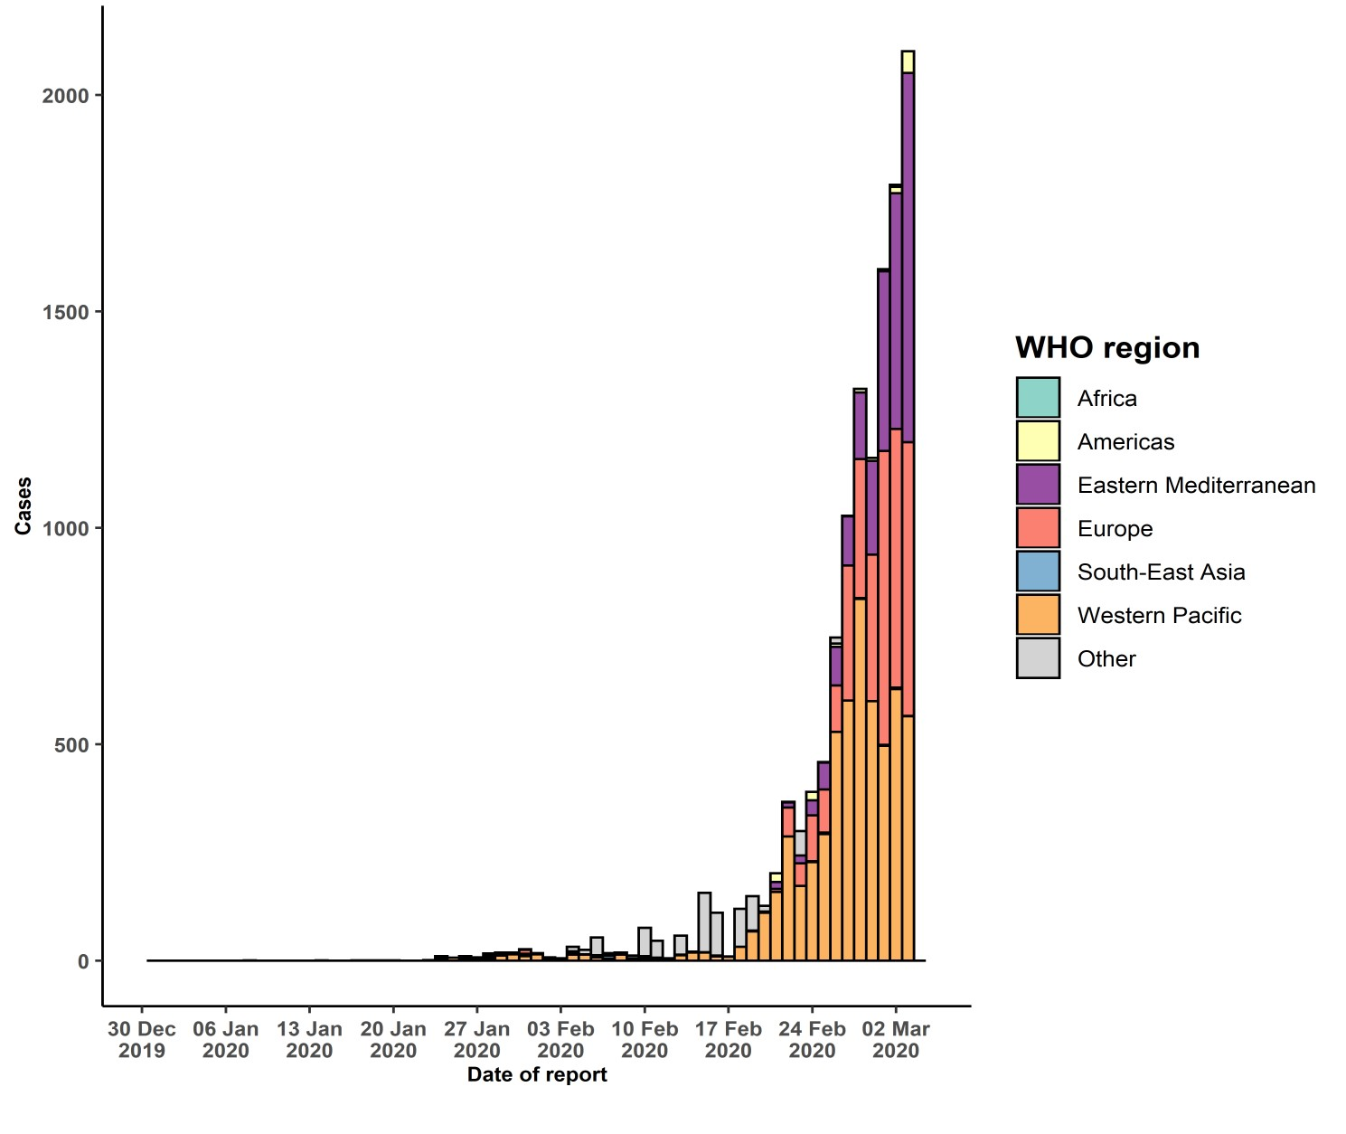
STRATEGIC OBJECTIVES

WHO’s strategic objectives for this response are to:

  - Interrupt human-to-human transmission including reducing secondary infections among close contacts and health care workers, preventing transmission amplification events, and preventing further international spread*;
  - Identify, isolate and care for patients early, including providing optimized care for infected patients;
  - Identify and reduce transmission from the animal source;
  - Address crucial unknowns regarding clinical severity, extent of transmission and infection, treatment options, and accelerate the development of diagnostics, therapeutics and vaccines;
  - Communicate critical risk and event information to all communities and counter misinformation;
  - Minimize social and economic impact through multisectoral partnerships.

*This can be achieved through a combination of public health measures, such as rapid identification, diagnosis and management of the cases, identification and follow up of the contacts, infection prevention and control in health care settings, implementation of health measures for travelers, awareness-raising in the population and risk communication.

PREPAREDNESS AND RESPONSE

- To view all technical guidance documents regarding COVID-19, please go to this webpage.
- WHO is working closely with International Air Transport Association (IATA) and have jointly developed a guidance document to provide advice to cabin crew and airport workers, based on country queries. The guidance can be found on the IATA webpage.
- WHO has been in regular and direct contact with Member States where cases have been reported. WHO is also informing other countries about the situation and providing support as requested.
- WHO has developed interim guidance for laboratory diagnosis, advice on the use of masks during home care and in health care settings in the context of the novel coronavirus (2019-nCoV) outbreak, clinical management, infection prevention and control in health care settings, home care for patients with suspected novel coronavirus, risk communication and community engagement and Global Surveillance for human infection with novel coronavirus (2019-nCoV).
- WHO is working with its networks of researchers and other experts to coordinate global work on surveillance, epidemiology, mathematical modelling, diagnostics and virology, clinical care and treatment, infection prevention and control, and risk communication. WHO has issued interim guidance for countries, which are updated regularly.
- WHO has prepared a disease commodity package that includes an essential list of biomedical equipment, medicines and supplies necessary to care for patients with 2019-nCoV.
- WHO has provided recommendations to reduce risk of transmission from animals to humans.
- WHO has published an updated advice for international traffic in relation to the outbreak of the novel coronavirus 2019-nCoV.
- WHO has activated the R&D blueprint to accelerate diagnostics, vaccines, and therapeutics.
- WHO has developed online courses on the following topics: A general introduction to emerging respiratory viruses, including novel coronaviruses (available in Arabic, English, French, Chinese, Spanish, Portuguese, and Russian); Critical Care of Severe Acute Respiratory Infections; and Health and safety briefing for respiratory diseases - ePROTECT (available in English and French); Infection Prevention and Control for Novel Coronavirus (COVID-19) (available in English and Russian); Critical Care Severe Acute Respiratory Infection (available in
English and French); and COVID-19 Operational Planning Guidelines and COVID-19 Partners Platform to support country preparedness and response.
- WHO is providing guidance on early investigations, which are critical in an outbreak of a new virus. The data collected from the protocols can be used to refine recommendations for surveillance and case definitions, to characterize the key epidemiological transmission features of COVID-19, help understand spread, severity, spectrum of disease, impact on the community and to inform operational models for implementation of countermeasures such as case isolation, contact tracing and isolation. Several protocols are available here: https://www.who.int/emergencies/diseases/novel-coronavirus-2019/technical-guidance/early-investigations One such protocol is for the investigation of early COVID-19 cases and contacts (the “First Few X (FFX) Cases and contact investigation protocol for 2019-novel coronavirus (2019-nCoV) infection”). The protocol is designed to gain an early understanding of the key clinical, epidemiological and virological characteristics of the first cases of COVID-19 infection detected in any individual country, to inform the development and updating of public health guidance to manage cases and reduce the potential spread and impact of infection.

RECOMMENDATIONS AND ADVICE FOR THE PUBLIC

If you are not in an area where COVID-19 is spreading, or have not travelled from an area where COVID-19 is spreading, or have not been in contact with an infected patient, your risk of infection is low. It is understandable that you may feel anxious about the outbreak. Get the facts from reliable sources to help you accurately determine your risks so that you can take reasonable precautions (See Frequently Asked Questions). Seek guidance from WHO, your healthcare provider, your national public health authority or your employer for accurate information on COVID-19 and whether COVID-19 is circulating where you live. It is important to be informed of the situation and take appropriate measures to protect yourself and your family (see Protection measures for everyone).

If you are in an area where there are cases of COVID-19 you need to take the risk of infection seriously. Follow the advice of WHO and guidance issued by national and local health authorities. For most people, COVID-19 infection will cause mild illness however, it can make some people very ill and, in some people, it can be fatal. Older people, and those with pre-existing medical conditions (such as cardiovascular disease, chronic respiratory disease or diabetes) are at risk for severe disease (See Protection measures for persons who are in or have recently visited (past 14 days) areas where COVID-19 is spreading).

CASE DEFINITIONS

WHO periodically updates the Global Surveillance for human infection with coronavirus disease (COVID-19) document which includes case definitions.

For easy reference, case definitions are included below.

Suspect case
- A patient with acute respiratory illness (fever and at least one sign/symptom of respiratory disease (e.g., cough, shortness of breath), AND with no other etiology that fully explains the clinical presentation AND a history of travel to or residence in a country/area or territory reporting local transmission (See situation report) of COVID-19 disease during the 14 days prior to symptom onset.
OR
- A patient with any acute respiratory illness AND having been in contact with a confirmed or probable COVID- 19 case (see definition of contact) in the last 14 days prior to onset of symptoms;
OR
- A patient with severe acute respiratory infection (fever and at least one sign/symptom of respiratory disease
(e.g., cough, shortness breath) AND requiring hospitalization AND with no other etiology that fully explains the clinical presentation.

Probable case
A suspect case for whom testing for COVID-19 is inconclusive.
  - Inconclusive being the result of the test reported by the laboratory

Confirmed case
A person with laboratory confirmation of COVID-19 infection, irrespective of clinical signs and symptoms.

Link for lab page: https://www.who.int/emergencies/diseases/novel-coronavirus-2019/technical- guidance/laboratory-guidance

